FAQ’S ABOUT THE GROVE
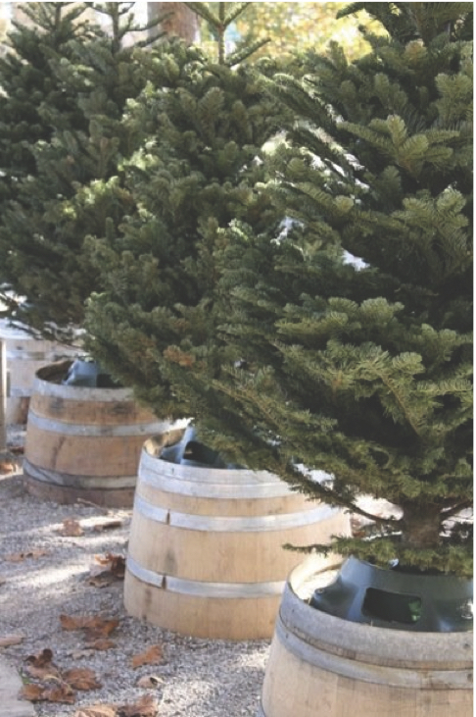
The Charlie Brown Christmas Tree Grove consists of 200 4-5’ decorated evergreen trees attached to tree stands on top of labeled ½ wine barrels. The trees line the walkways on Windsor Town Green during the month of December.

1. How do I reserve a tree? Businesses, non-profits, classrooms, groups, clubs, families or individuals may reserve trees from September 1 through October 31 by forwarding a completed entry form and fee to Windsor Parks and Recreation Foundation, 228 Windsor River Rd., #226, Windsor, CA 95492, or dropping the form and fee off at Powell’s Sweet Shoppe located at 720 McClelland Avenue, Windsor, CA 95492. Forms can be found at Powell’s Sweet Shoppe or on-line at people4parkswindsor.org, olddowntownwindsor.com and townofwindsor.com/special events after September 1. Reservations will not be accepted without the applicable fee, are processed on a first-come, first-served basis and limited to 200 spots. We do not accept cash payments. Make checks payable to Windsor Parks and Recreation Foundation.
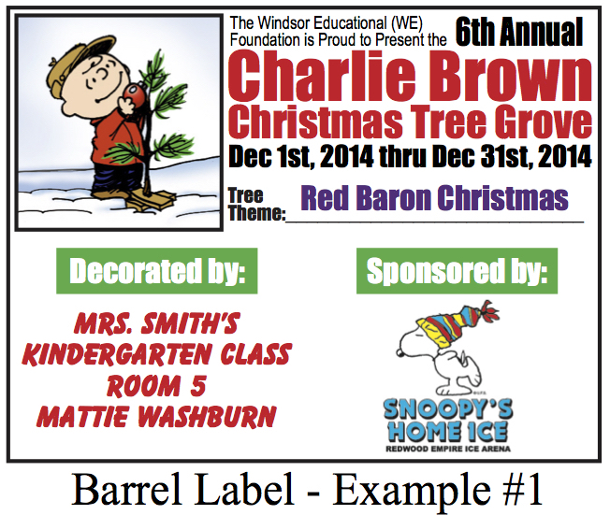
2. May I sponsor a tree for someone else? Yes. You, your group or business can sponsor a tree for another individual, family, neighborhood, club, classroom, non-profit, etc. There is a space on the entry form to indicate if you choose to reserve a tree for a different participant. If you want to sponsor but don’t have a group or person in mind, just indicate on the form and we will find a worthy recipient of your generous donation to decorate your tree.
3. Can I get someone to sponsor me or my group? Yes. There is space on the entry form to indicate if you are seeking someone else to sponsor your tree. The Foundation will do our best to match you with a donating sponsor but there are no guarantees that one will be found. Please consider soliciting and identifying a sponsor before submitting the entry form.
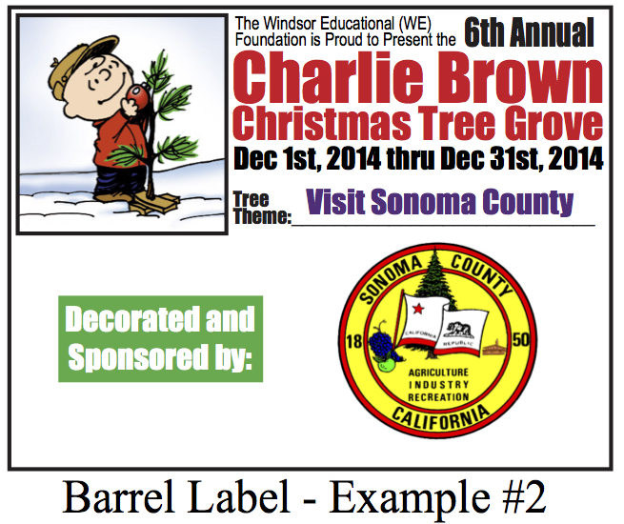
4. What is the fee and what is included? The fees on the entry form are tax-deductible donations to the Windsor Parks and Recreation Foundation, a 501(c)(3) nonprofit CA corporation. The donation will be recognized by a laminated 8 ½ x 11 label on the wine barrel stand identifying the donor and sponsored participant (if not the donor). If the donor wants their logo to appear on the label with their name, the logo should emailed as a pdf or jpeg file to people4parkswindsor@gmail.com. The Foundation provides all trees assembled in stands and a single red bulb in honor of Charlie Brown. Other tree decorations are the responsibility of the participant.
5. Who decorates the tree and when? The trees will be assembled and available for decorating the Sunday afternoon following Thanksgiving. If the donor chooses not to decorate their tree, they will be responsible to arrange for their sponsored participant to do the decorating. If the Foundation has matched donor and sponsored participant, the Foundation will arrange for the sponsored participant to do the decorating. Decorations must be completed by 5 PM the first Wednesday in December.
6. What kind of decorations can be used? Exterior LED lighting is required by the Town of Windsor, who generously provides electrical service for the Grove. If non-LED lights are found on a tree during the event they will be disconnected and flagged for removal. Due to the shared and limited nature of electrical power to the Grove, no transformers are allowed. Extension cords, if necessary, must be exterior-rated and taped down. All decorations must be weatherproof and firmly attached to branches to withstand windy and wet conditions which are common occurrences in the month of December. You are encouraged to be creative in your choice of theme for your tree. Handmade ornaments are recommended to be laminated and/or made with Gorilla Glue (no Elmer’s Glue or Rubber Cement as these dissolve). Tinsel is not allowed. Decorations that fall off trees will be discarded by Maintenance staff so please check and adjust your tree after any bad weather. You are also responsible for decoration removal.
7. Can I provide my own tree or holiday symbol? Yes. Please indicate on the form if you choose to bring your own Holiday symbol or live or artificial tree. A barrel and laminated label will be provided but you will be responsible to provide your own tree stand and assemble your own decoration or tree on the barrel so that it is stable. Symbols such as Menorahs that are not trees must not take up space larger than a 4-5’ tree and must be Holiday related. If you bring your own tree, it must not be larger than 5’. Entries must be pre-approved by the Foundation before placement.
8. What is the timeline for the Grove?
September 1 through October 31 – Entry forms available and accepted
2-4 PM on Sunday after Thanksgiving – trees available for decorating. Go to check-in desk near East Pavilion for location of your tree. You must show the check-in volunteer your LED lights before receiving permission to decorate.
First Wednesday in December by 5 PM – tree decorations must be complete. Undecorated trees will be given by the Foundation to another party after this date.
First Thursday in December – special Grove events at Town of Windsor’s Holiday Celebration on the Green
New Year’s Day – begin removing decorations from tree
2 PM on first Saturday after New Year’s – deadline for decoration removal. Decorations will be discarded with trees after this time.

